STATE BAR OF NEVADA

PARALEGAL DIVISION

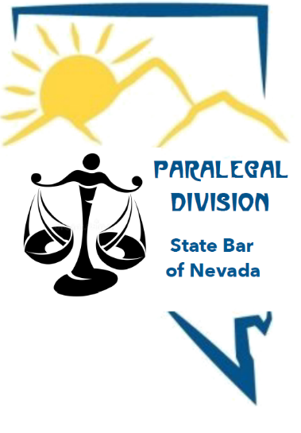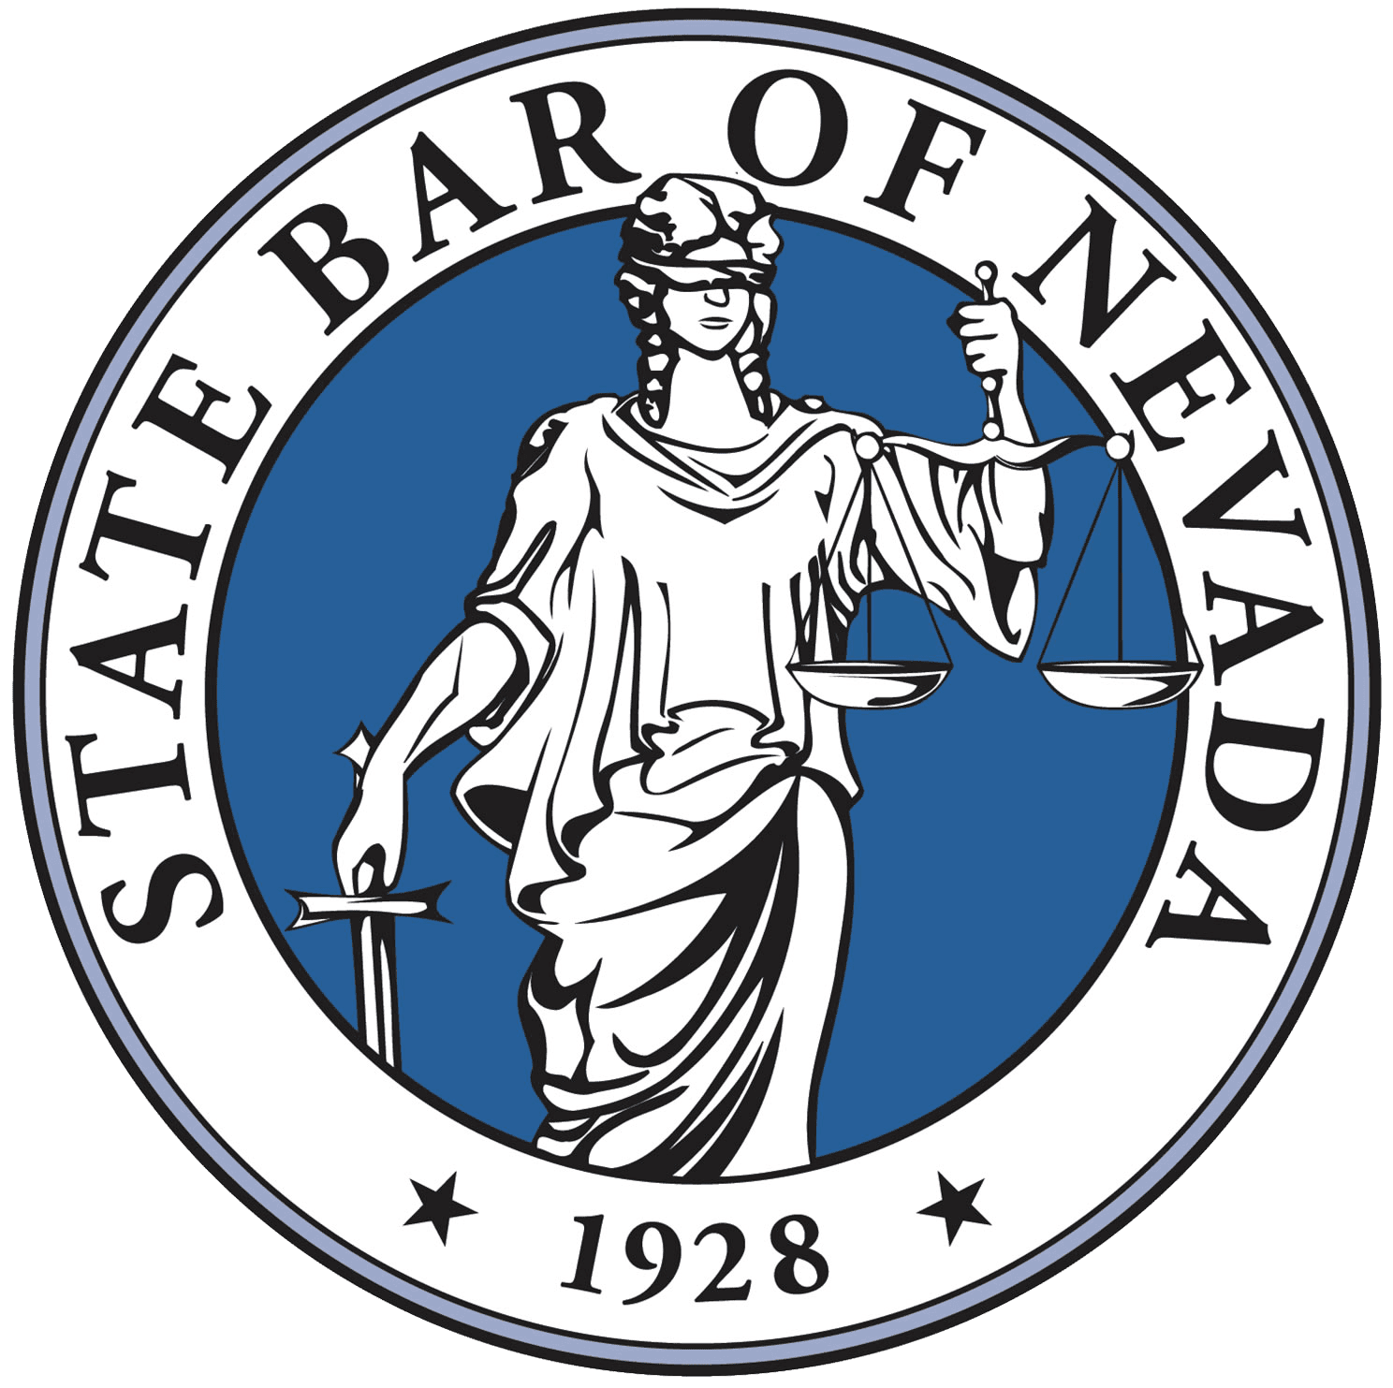

**OUR PURPOSE**

To enhance the participation of paralegals in the administration of justice, professional responsibility, and public service; establish good fellowship among Division members and members of the legal community; encourage a high order of ethical and professional attainment; further education among members of the profession; and, to cooperate with local bar associations.

**WHO MAY JOIN**

Legal professionals who are looking to advance their careers, should join the Paralegal Division of the State Bar of Nevada.  The division welcomes new members who have an interest in networking, continuing legal education, and professional growth opportunities.  Membership to the Paralegal Division of the State Bar of Nevada is now open to all legal professionals including Paralegals, Legal Assistants, Legal Secretaries, Paralegal Students, Law Clerks, Law Students and Legal Administrators.  This is not a complete list, however, if you believe you may be called a “legal professional” you are welcome and encouraged to join.

**HOW TO JOIN**

Search for [www.nvbar.org](https://protect-us.mimecast.com/s/w1nyCG6EE1IAL96jh0viSr?domain=nvbar.org) then choose, “Attorney Login”, next choose “Create Non-Attorney Account” and follow the prompts.  Once this has been completed, please then contact the State Bar of Nevada via email at [memberservices@nvbar.org](mailto:memberservices@nvbar.org)or telephonically at (702) 382-2200 and ask to have an invoice created for the $25.00 yearly membership fee and added to your account.  An email will then be sent prompting you to login using your new credentials and pay the invoice. Once your membership dues are paid the membership process is complete and you will now be a member of the Paralegal Division of the State Bar of Nevada.

As a special note, our division is one of only five paralegal sections to be included in a State Bar in the United States, therefore, membership in our division is quite prestigious.

**CONTACT INFORMATION**

[nevadabarparalegal@gmail.com](mailto:nevadabarparalegal@gmail.com) or (702) 229-2351