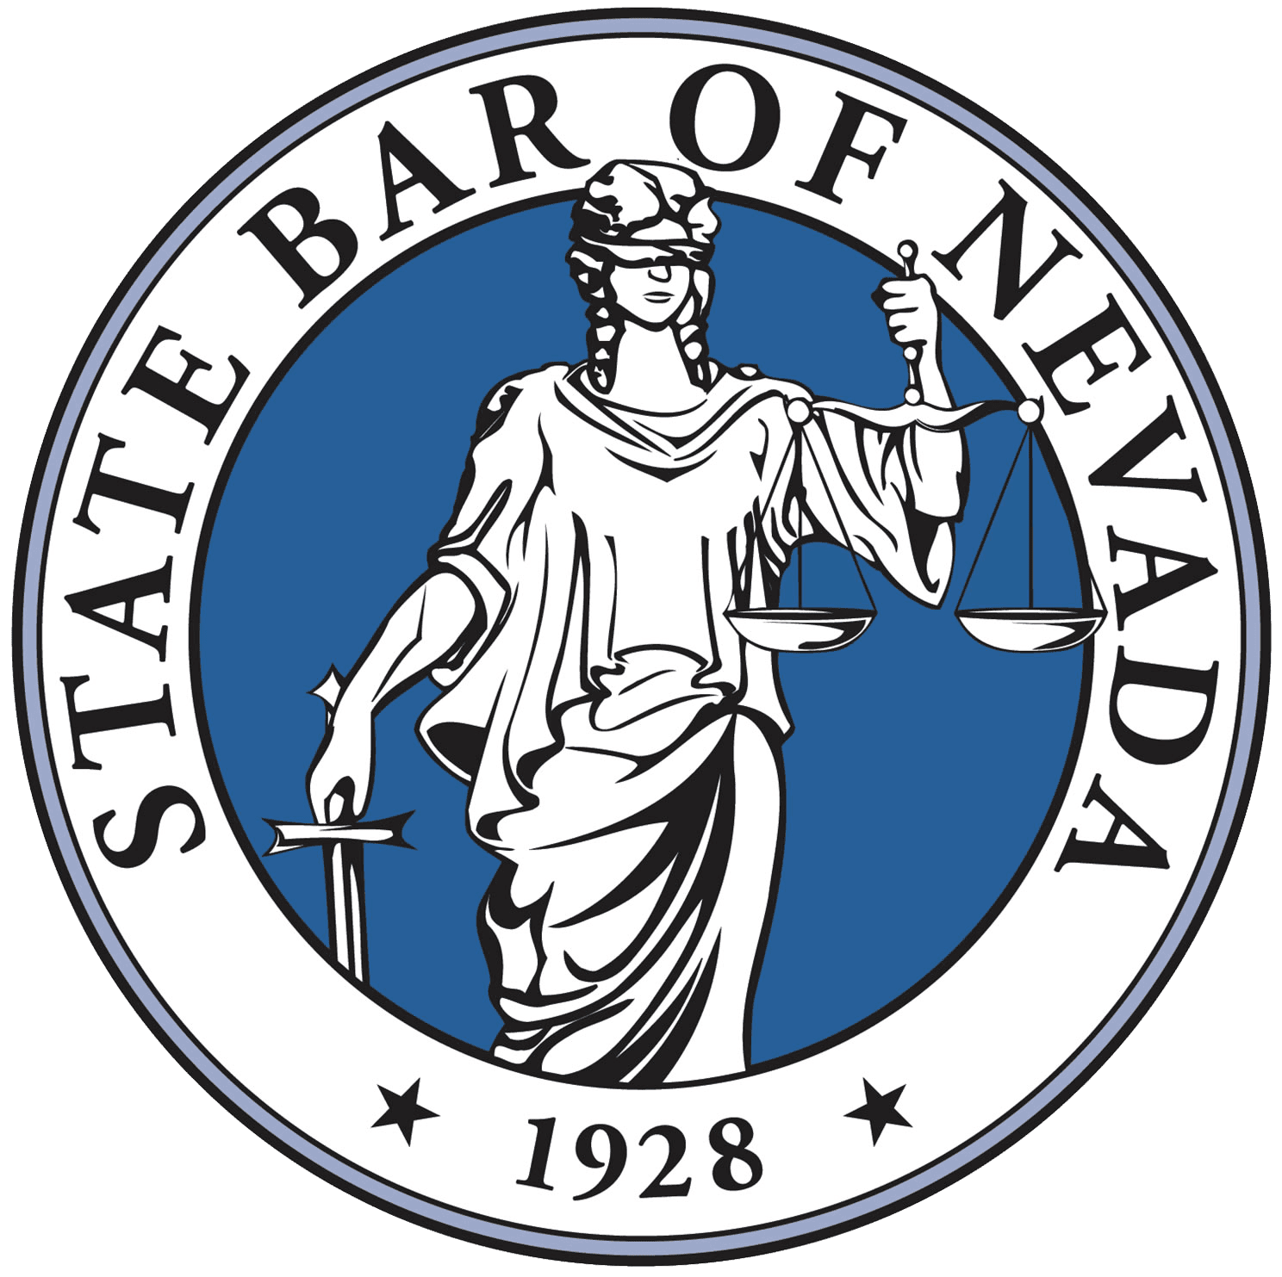
Public Lawyer’s Section 2023 Annual Meeting Minutes
September 8, 2023, at 8:00 a.m.
Bally’s Hotel and Casino – South Lake Tahoe

I. Call to Order and Roll Call
Meeting called to order by Chair Sarah Bradley at 8:31 a.m.
II. Chair Report
Chair Bradley shared information from the Nevada State Bar Conference in New York City.

Secretary Michael Oh stated that a committee will be formed by the Public Lawyer’s Section to create a strategic plan for the Section and to develop the Mission Statement to align with the goals of the State Bar’s Strategic Plan.

Summary provided by Board of Governors Marisa Rodriguez and Holly Parker on the State Bar’s Strategic Plan. Information was shared about the therapy benefit available for all State Bar members that is anonymous. The benefit provides three one-hour therapy sessions at no cost to the State Bar member. Marisa and Holly also mentioned the Calm wellness App that is available to all members at no-charge.

Chair Bradley shared results of the Pro Bono Challenge. The LGBT Section won the Challenge. Homa Woodrum was the top volunteer from the Public Lawyers’ Section, and she will be invited to a celebratory lunch with the Nevada Supreme Court and Nevada Court of Appeals this fall.

III. Nomination and Election of Officers and Executive Council. (Sarah)
Chair Bradley went over the descriptions for each office. Vice-Chair Melissa Flatley and at-large members Micaela Moore will be stepping down from the Executive Council. Melody Luetkehans resigned from the Executive Council on June 23, 2023. Chair Bradley opened up the nominations for the positions.

No new nominations received for the position of Chair.

Micaela Moore nominated Michael Oh for the position of Vice-Chair and Andy Moore to one of the open At-Large positions.

Michael Oh nominated Jeffrey Dorocak for Secretary or At-Large member. Jeff Dorocak accepted the nomination for Secretary.

Micaela Moore nominated Bethany Sanchez for the position of At-Large member.

Sophia Long and Jill Davis indicated that they were still willing to serve as At-Large members.

Janet Traut moved to accept the nominations and that the Section elect the following slate to the Executive Council:

Chair: Sarah Bradley
Vice-Chair: Michael Oh
Secretary: Jeffery Dorocak
At-large members: Jill Davis, Bethany Sanchez, Andrew Moore, and Sophia Long.

Janet’s motion was seconded by Ian Cummings.

Motion passed by unanimously vote.

IV. Amendment to bylaws
Chair Bradley went over the proposed changes to the Bylaws. Some of these changes were requested by the State Bar, such as addressing succession planning and offering membership to law students. This proposal also created a new category of membership for law school graduates working in public agencies in Nevada who are not yet members of the Nevada Bar. This would include law clerks who may be waiting for Bar results and other law school graduates who are not yet members of the Nevada Bar employed by public agencies, such as the Department of Justice or Legislative Counsel Bureau. The other changes were removing outdated language from the Bylaws such as conducting special elections by mail. If the proposed changes to the Bylaws are approved by the Section, then the new Bylaws will go to the Board of Governors for final approval.
Motion to approve the changes to the Bylaws as shown in Exhibit 1, attached hereto the minutes, by Ian Cummings. Motion seconded by Janet Traut. Motion passed unanimously.
V. 2023-2024 Action Plan
Chair Bradley discussed a proposed increase in Section dues for members of the Nevada Bar from the current amount of $25 to $50. It was recommended that dues be set at $50 for law school graduates and at no cost for active law students.
Much discussion among the membership ensued regarding this increase. Some members suggested that the State Bar should decrease the cost of Bar dues for public lawyers because many public lawyers pay their own Bar dues and this reduction in cost would increase their ability to join affinity bars. Marisa Rodriguez encouraged membership to participate in Board of Governors meetings in order to provide comment on this issue.
Brian Anderson asked whether the annual dues are the only source of revenues. Chair Bradley confirmed that annual dues are only revenue source and the annual conference costs have increased over the years. Brian Anderson suggested raising funds from private sources. Secretary Oh mentioned plans to solicit donations from private firms and/or vendors to help increase revenue sources.
Chair Bradley went over Revenue and Expenses for the 2023 conference as well as the donations received from government entities. Chair Bradley indicated that without the donations, we would have been in the negative for the 2023 conference and that we were likely to break even this year.
Motion by Homa Woodrum to increase annual section dues to $35 for members of the Nevada Bar, charge $35 for the new membership category of law school graduates, and charge no cost for the new membership category of current law students. This motion was seconded by Ian Cummings. Motion passed with a majority of the membership voting in favor of the motion. There were at least four Nayes from the Zoom feed noted on the record.
VI. 2024 Conference
Chair Bradley discussed options for conference for 2024 Civil Government Conference. Asked whether there was interest in having it in other areas of Nevada. Motion made by Janet Traut to have the conference in Lake Tahoe in 2024 and to explore having the conference in Southern Nevada the following year. Motion Seconded by Ian Cummings. Motion passed unanimously.
VII. Donation to Pro Bono Organization in lieu of Bartley Award (All)
Chair Bradley stated that there was no recipient for the Bartley Award. In lieu of the Bartley Award, Chair Bradley suggested that a donation of $500 be made from Section funds to a pro bono provider in Nevada.
Motion made by Jim Penrose to donate $500 to Volunteer Attorneys of Rural Nevada (VARN). Second by Homa Woodrum. Motion passed unanimously.
VII. Meeting adjourned at 9:35.

