BECOME A STATE BAR OF NEVADA PARTNER IN DIVERSITY, EQUITY, AND INCLUSION!
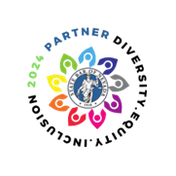The State Bar of Nevada recognizes the commitment that law firms and legal organizations have made to incorporating diversity, equity, and inclusion (DEI) initiatives in their practices. We invite law firms to display their commitment to DEI by becoming a 2024 Partner in Diversity, Equity, and Inclusion by proudly displaying this medallion on your firm’s website, marketing materials, or anywhere else you would like to promote your commitment to DEI!

HOW TO EARN THE DEI MEDALLION

The State Bar of Nevada has identified a variety of initiatives that qualify for the medallion. Qualification is earned annually. To earn the 2024 Partner in Diversity, Equity, and Inclusion medallion, firms must attest to having completed at least 5 initiatives.

Once we receive your completed form, we will email the medallion and you’re set to post it prominently, whether it be on your website, letterhead, or social media feeds.

WE’LL RECOGNIZE YOU, TOO!

Being your partner in DEI goes beyond this awesome seal. When you earn the 2024 Partner in Diversity, Equity, and Inclusion medallion we will announce your accomplishment through posts in the bar’s weekly eNews, in the Nevada Lawyer magazine, on our website, and through our social media channels. Don’t forget to follow us on Facebook, LinkedIn, and Twitter and share the good news!

QUESTIONS? WE HAVE ANSWERS

For questions on how to earn the 2024 Partner in Diversity, Equity, and Inclusion medallion, or to suggest future initiatives that may qualify, contact Diversity and Programs Manager Judi De Marco at judid@nvbar.org or at 702-317-1404.
SEND MY MEDALLION! 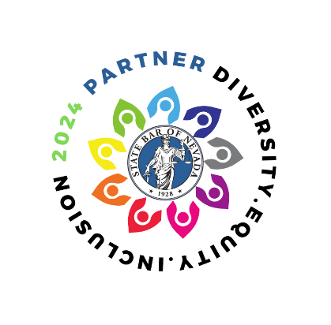

Our firm attests to completing at least five of the DEI initiatives listed below (checked).

Firm/Organization:
Contact Person:
Email Address:
Phone Number:

RECRUITMENT PRACTICES
☐ Actively recruit diverse applicants through affinity bar associations.
☐ Follow the Mansfield Rule 5.0 by considering 30-50% of unrepresented talent for all leadership positions and the activities that lead to leadership.
☐ Establish a summer internship program for law school students representing minority populations.
☐ Recruit from historically black colleges and universities (HBCU) law schools.
☐ Recruit from minority job fairs, such as the Southeastern Minority Job Fair or the Equal Justice Works Career Fair (public interest lawyers).

RETENTION PRACTICES
☐ Establish one or more committees focused on empowering women and minorities to advance into leadership positions.
☐ Celebrate historical milestones for minorities through guest speakers, catering traditional food from local eateries owned by diverse entrepreneurs, or hosting round table discussions on the significance of these days in the legal profession.
☐ Provide all new hires with a mentor (not a supervising attorney) responsible for encouraging participation in firm events and who can provide guidance about firm culture.
☐ Create “safe spaces” to discuss newsworthy events and actively listen to the perspectives shared by attorneys and staff from different backgrounds.
☐ Establish a formal training ‘academy’ for all new hires, introducing and spending time with each firm practice group, learning the firm culture, and outlining a path for advancement within the firm.
☐ Adopt flexible work arrangements, such as alternate work schedules and job shares, to address the diverse individual needs of attorneys and staff.
☐ Offer billable credit hours for participation in DEI activities within the office and in the community

PIPELINE AND COMMUNITY INITIATIVES
☐ Invest or actively participate in local school programs to promote law as a future profession (i.e., work study programs, school reading weeks, career days, etc.)
☐ Commit to serving as a high school mock trial coach at a school in an underserved community.
☐ Invest in the Justice Michael Douglas Pre-Law Fellowship program.
☐ Sponsor or participate in an affinity bar event, such as a social mixer, annual gala, or walk/run event.
☐ Participate in community clothing drives providing professional clothing for lawyers and staff, or other professionals in the community.
☐ Participate in an Ask-A-Lawyer event hosted through a legal aid provider.
☐ Take a pro bono case through a legal aid provider.

COACHING AND TRAINING
☐ Participate in the State Bar of Nevada’s 21-Day Diversity Challenge.
☐ Host coaching sessions/workshops on topics such as DEI awareness, recognizing unconscious bias, or having difficult conversations.
☐ Commit to having 100% of the firms’ local attorneys attend 3 CLE programs covering DEIA.

OTHER
☐ If your firm has a DEI initiative not listed here, drop us a line. We will happily review and add it to our list!

ACKNOWLEDGEMENT & PERMISSION

☐ Our firm/legal organization represents that all activities checked are reported in the spirit and intent of the State Bar of Nevada’s DEI medallion program.
☐ We grant permission for the State Bar of Nevada to promote our firm/legal organization as having earned the 2024 DEI medallion in its publications and social media outlets.

Name: |  | Signature:
Date:

